CE203 Assignment GUI Output Testing:
Summary:
In this assignment I had to create an GUI that can generate a polygon. The polygon can be any size with any angle and can have as much numbers of sides, each polygon I given a designated ID number that must be 6 digits. The application layout I made is a little different to the one on the assignment brief as my one is small and the user needs to expand it however from what described in the assignment brief it works as intended.

The GUI Layout:
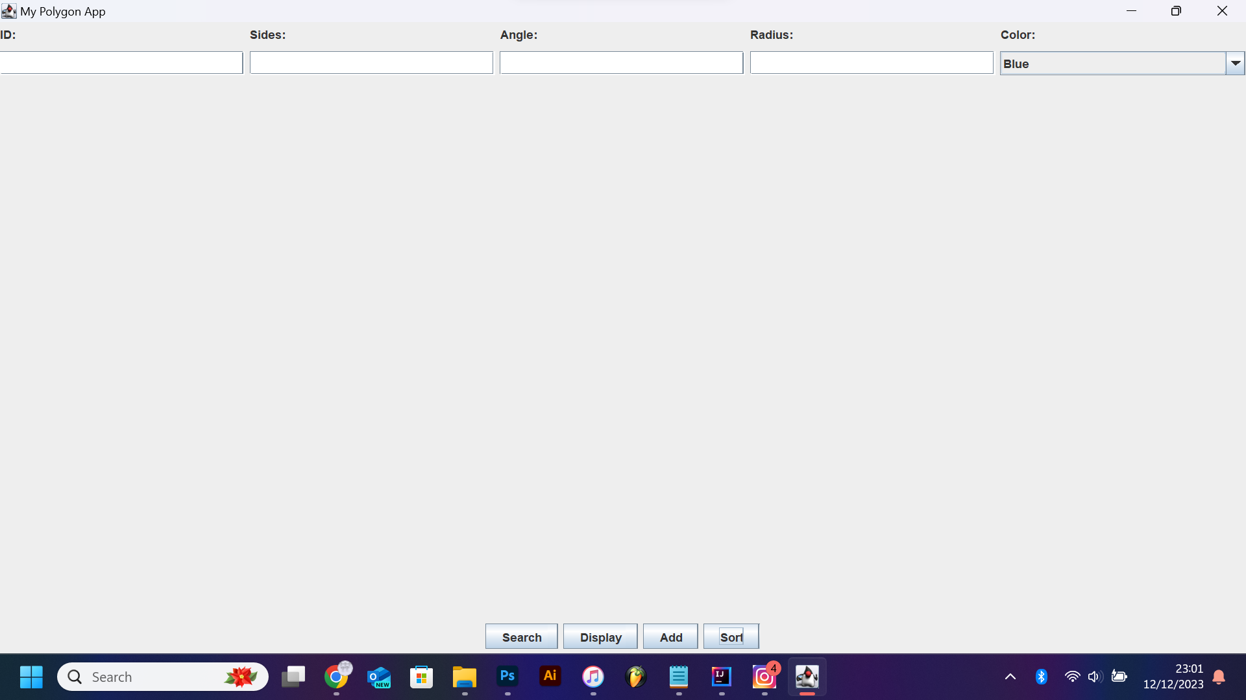
(This is the GUI In full screen)
Adding a Polygon:
With the given values If the user presses add the values will be stored in the regpolygon class and It would be stored in the arraylist. 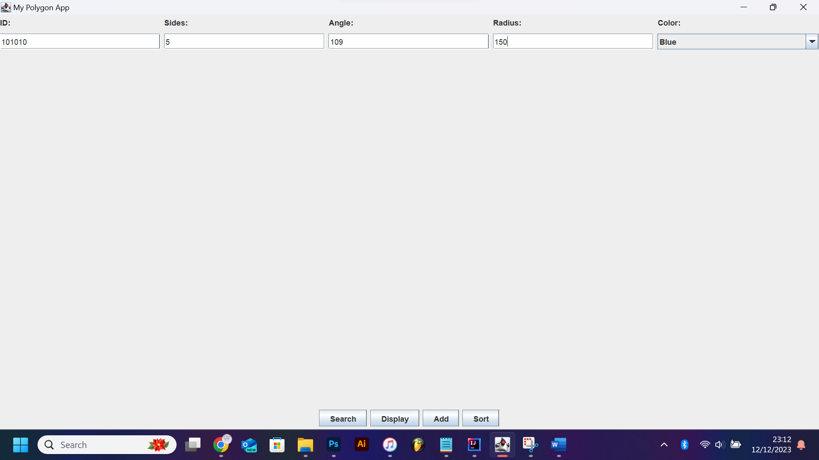
If the user tries to enter a lets say 5 digit ID they would be met with an error in the GUI and also on the console:
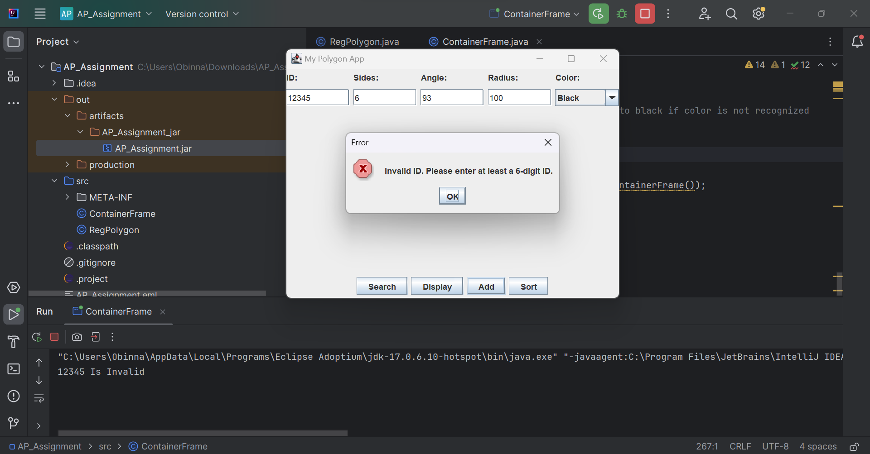
If the user adds a number less than or equal to 4 they will be met with an error telling them to put a number higher than 4.
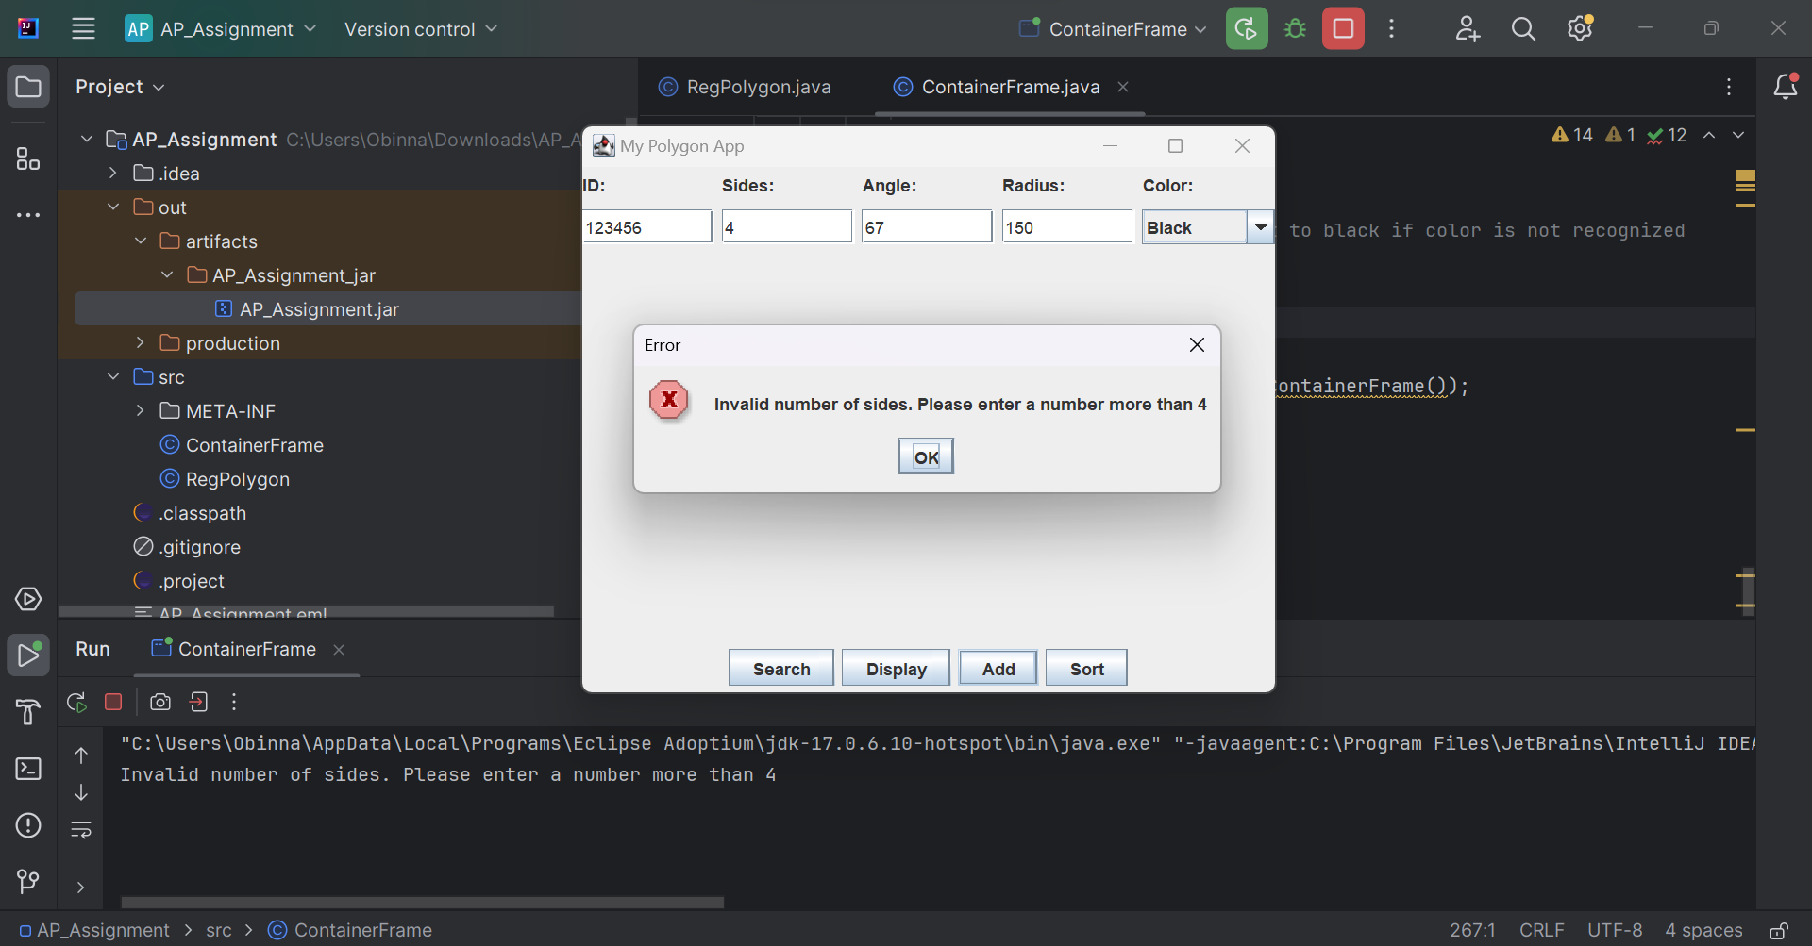
If a user puts invalid values so for example lets say they forgot about the radius then the console would give a message saying please input the right values:
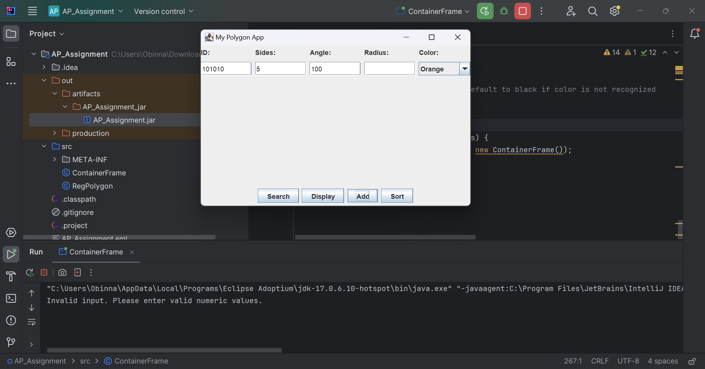
Displaying a polygon:
The application will display the last polygon added to the arraylist so when you add a polygon and press display it will show the polygon:
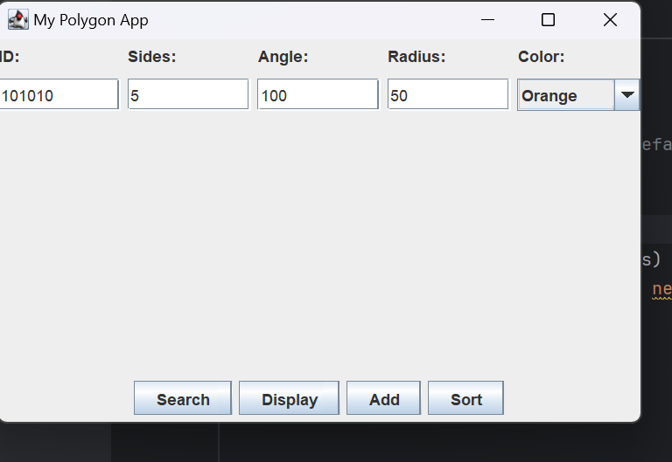
This is the polygon added to the arraylist
Now when I press display this is what you would see:
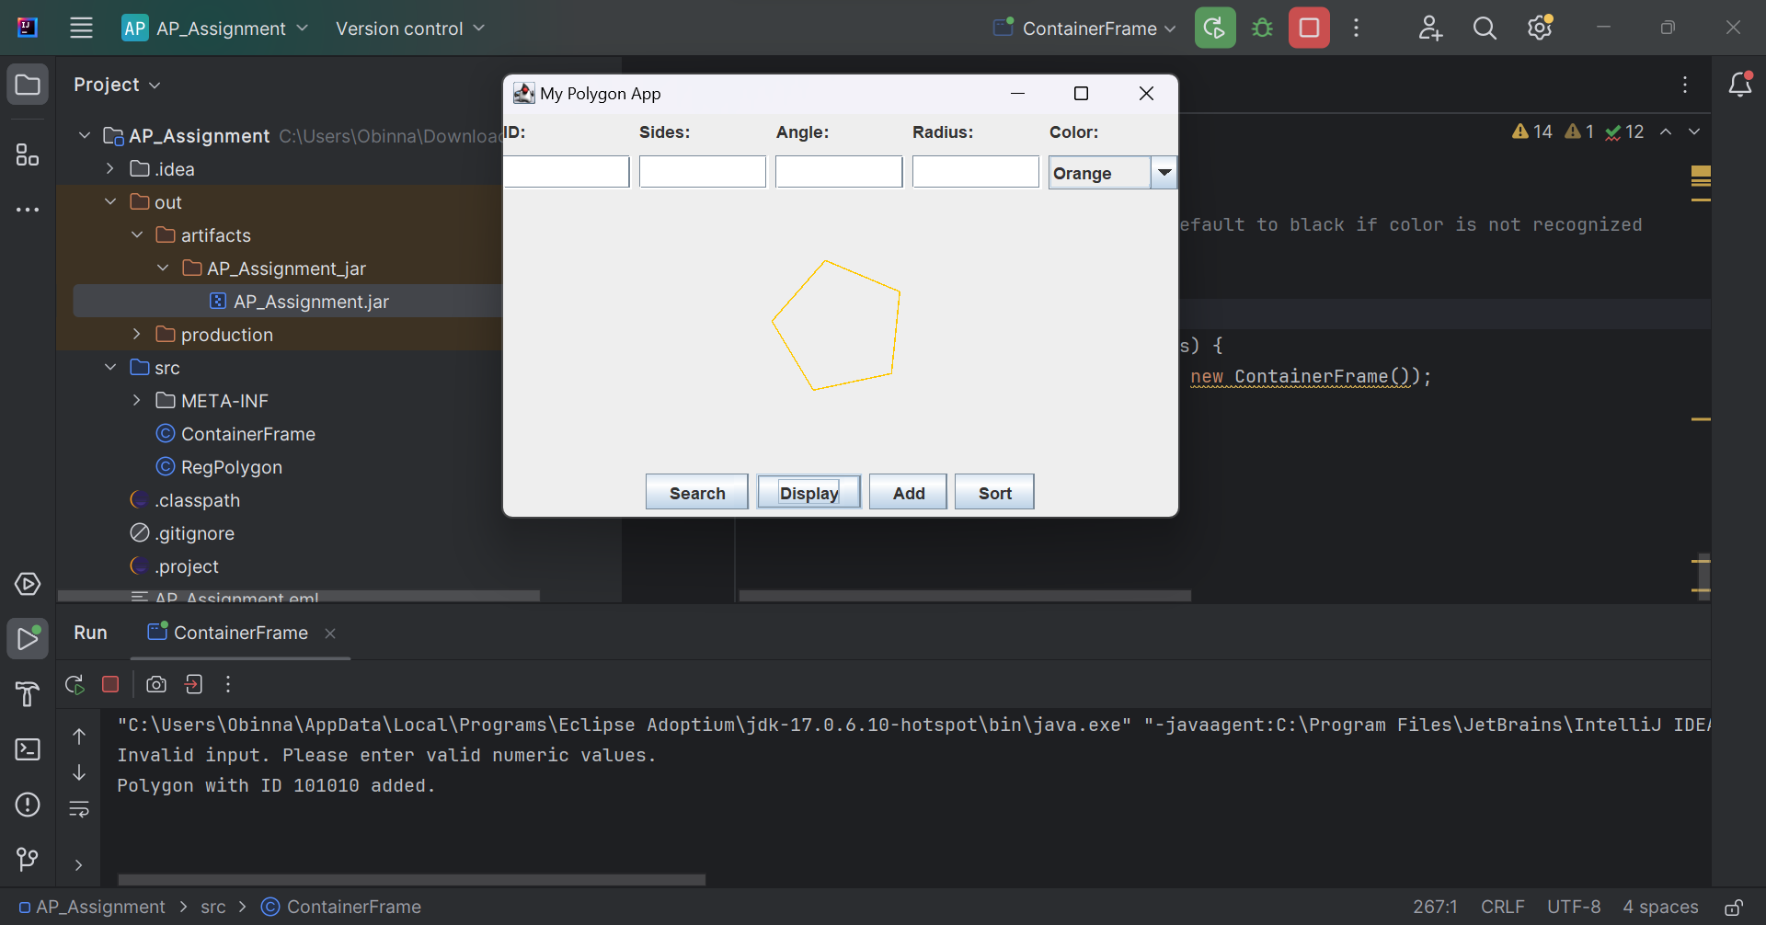
Searching and displaying a polygon by the ID
When I input the ID of a polygon in the arraylist in the ID text field and click the search button what would happen is that it would display that polygon and on the console it will tell you the number of sides, radius, angle and the colour. With the colour it gives you the colour code instead of giving it in string.
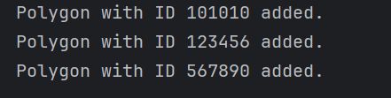
I am going to search the polygon with the ID: 567890
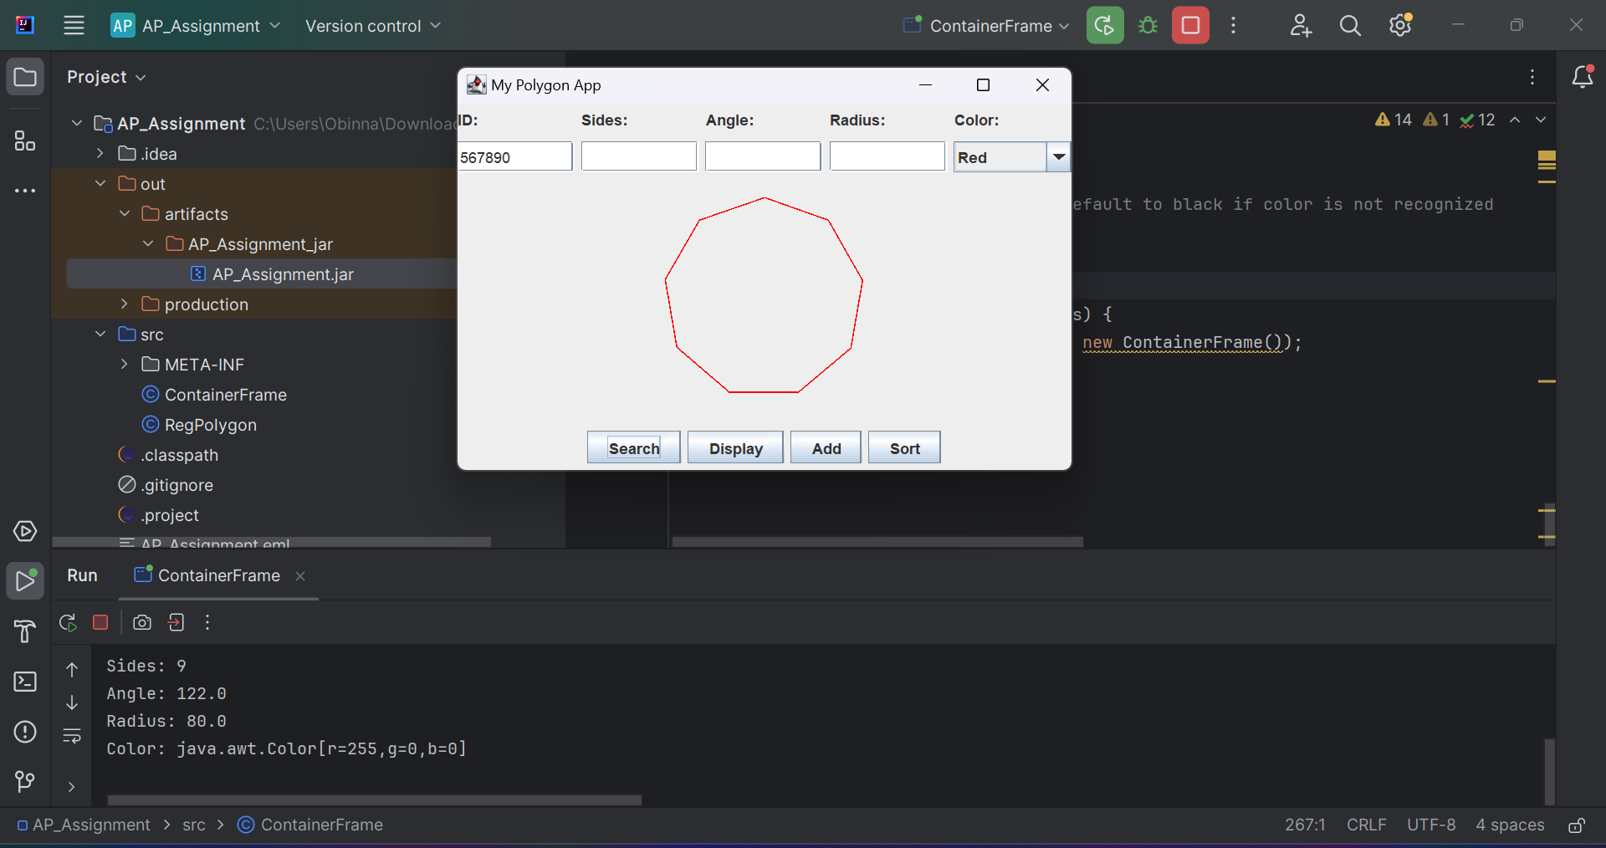
If I enter an invalid ID I should get an message on the console:
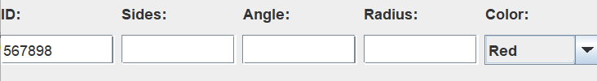
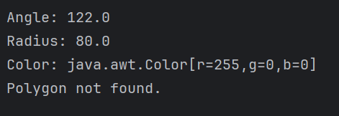
Sorting The Polygons
This button sorts the arraylist from ascending order I am going to add more polygons to the list and then sort them. I have added 3 more polygons so there should be 6 in the array.
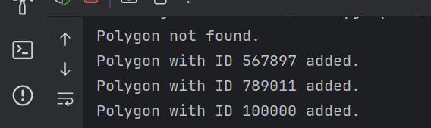
Now when I press sort It would be sorted so I will imagine the polygon ID 100000 will be first.
